

Data and Artificial Intelligence
Cyber Shujaa Program

Week 3 Assignment
Titanic Exploratory Data Analysis in Python

Student Name: Amidu Dabor
Student ID: CS-DA01-25031
Date: 6 June, 2025

Table of Contents
1.0 Introduction 1
2.0 Task Completion 1
2.1 Initial Data Exploration 1
2.2 Data Quality Assessment 3
2.3 Handling Missing Values 5
2.4 Univariate Analysis 6
2.5 Bivariate Analysis 10
2.6 Multivariate Analysis 13
2.7 Outlier Detection and Handling 15
2.8 Target Variable Analysis 18
3.0 Key Insights and Findings 20
Major Findings: 20
Data Quality Summary: 21
4.0 Kaggle Notebook Publication 21
4.1 Public Link to Kaggle Notebook 22
5.0 Conclusion 22
6.0 References 23
7.0 Appendices 23
Appendix A: Complete Code Listing/Implementation 23
Appendix B: Imported Libraries and Configuration 23

1.0 Introduction
The RMS Titanic disaster remains one of the most infamous maritime tragedies in history. On April 15,1912, the "unsinkable" ship collided with an iceberg during its maiden voyage, resulting in the loss of 1,502 lives out of 2,224 passengers and crew. This exploratory data analysis (EDA) investigates the factors that influenced passenger survival rates using the famous Titanic dataset from Kaggle.

Objectives
The primary objectives of this analysis are to:
- Understand the dataset structure and identify data quality issues
- Explore relationships between features and survival outcomes
- Handle missing values and outliers appropriately
- Identify key factors that influenced survival rates
- Prepare the dataset for future predictive modeling
This analysis follows a structured approach using object-oriented programming principles in Python, employing libraries such as pandas, numpy, matplotlib, seaborn, and scipy for comprehensive data exploration and visualization.

2.0 Task Completion

2.1 Initial Data Exploration
The initial exploration phase involved understanding the dataset's structure, dimensions, and basic characteristics.
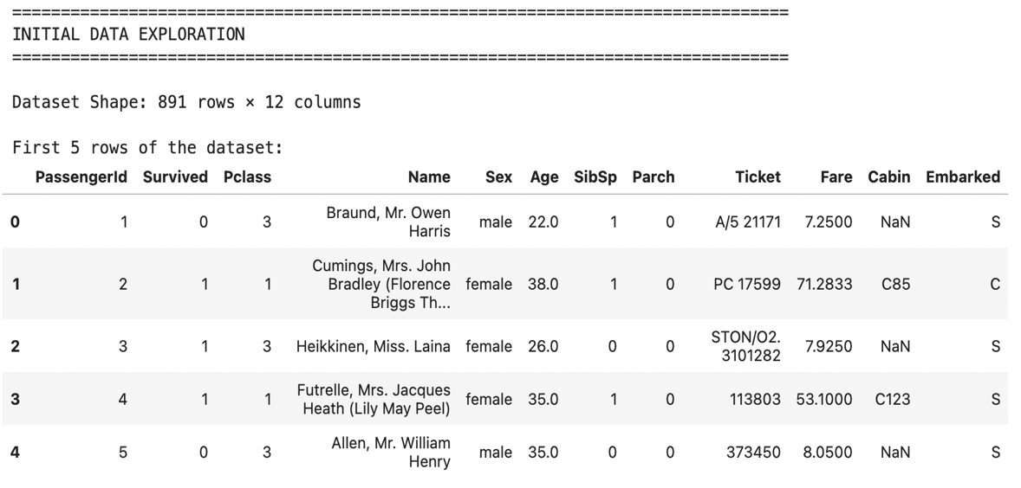
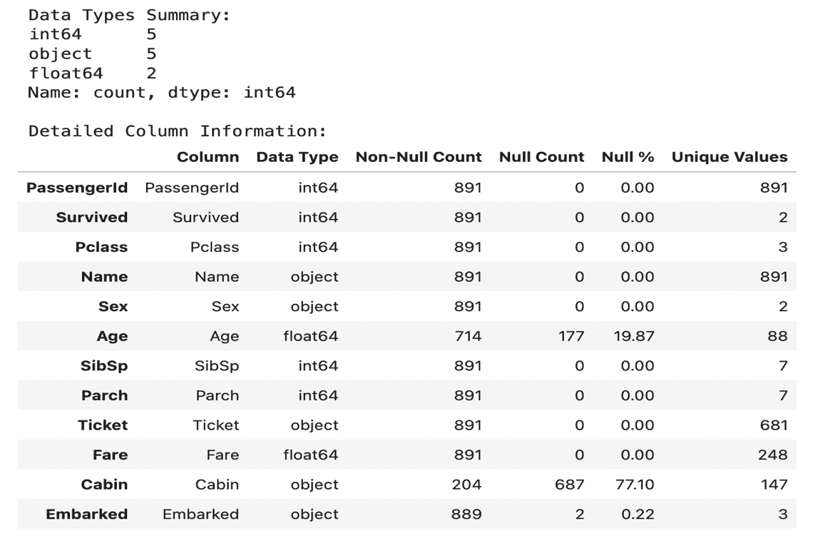
The dataset contains various feature types:
- Numerical: Age, SibSp, Parch, Fare
- Categorical: Survived, Pclass, Sex, Embarked
- Text: Name, Ticket
- Mixed: Cabin (contains both deck letter and room number)
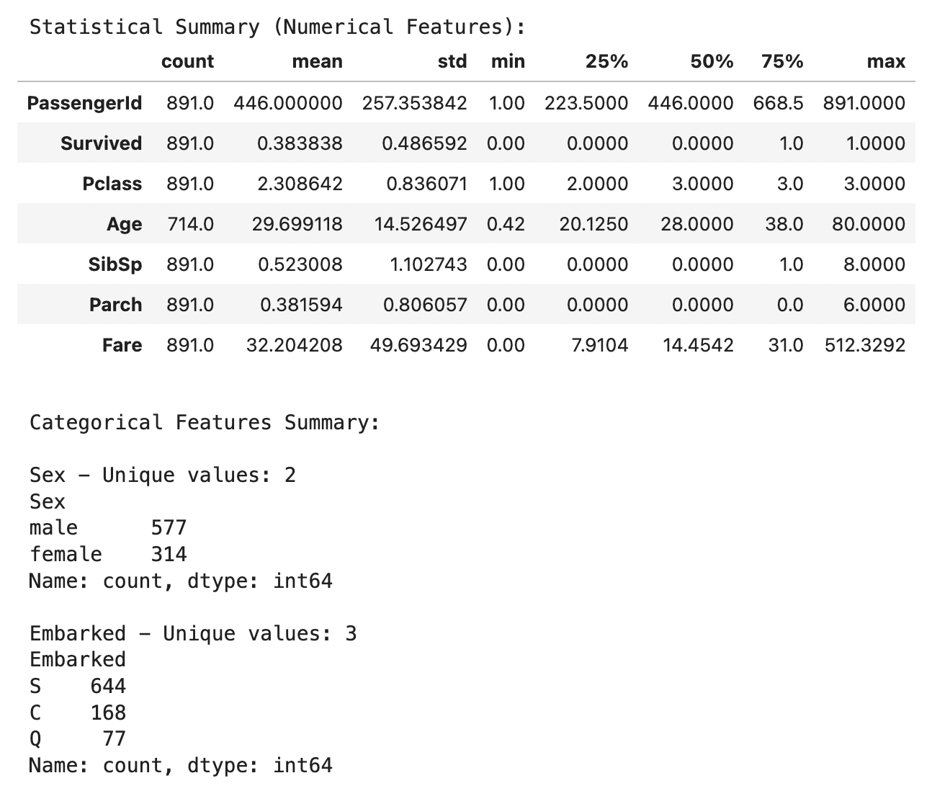

2.2 Data Quality Assessment
A comprehensive data quality check was performed to identify potential issues.
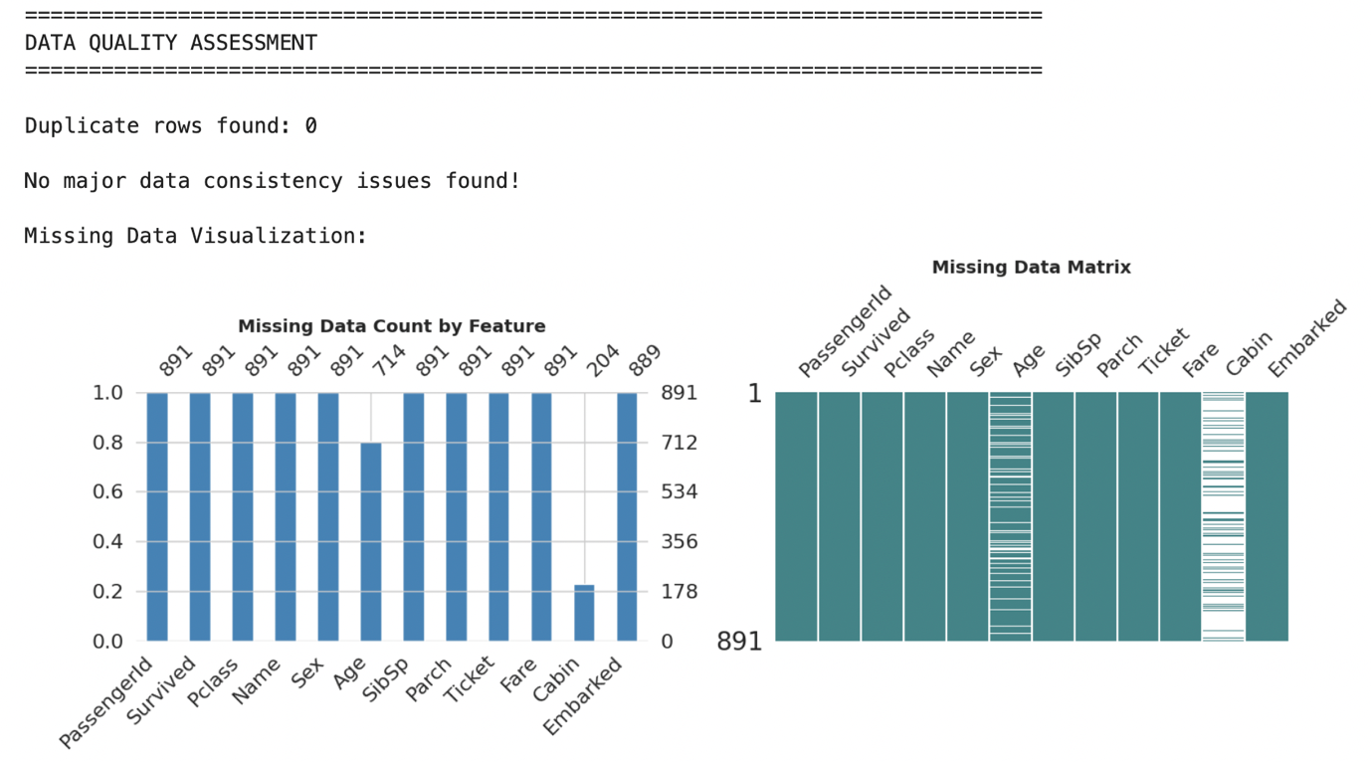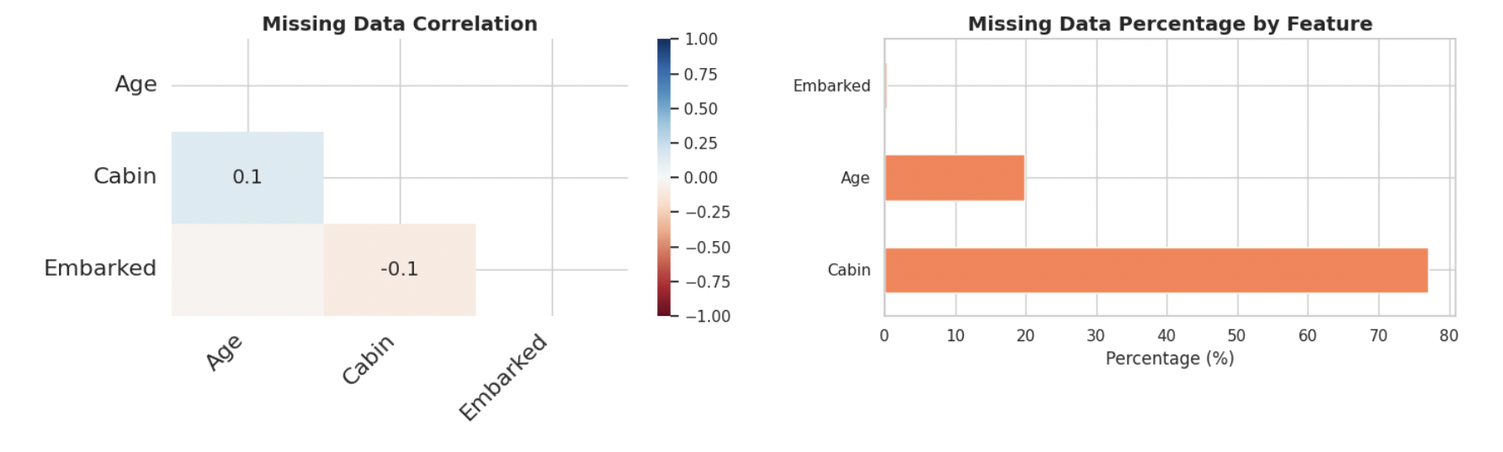
Key Findings:
- No duplicate records were found in the dataset
- Missing values were present in three columns:
- Cabin: 77.1% missing (687 out of 891)
- Age: 19.9% missing (177 out of 891)
- Embarked: 0.2% missing (2 out of 891)
- No major data consistency issues were identified

2.3 Handling Missing Values
Different strategies were employed for handling missing values based on the nature and extent of missingness.

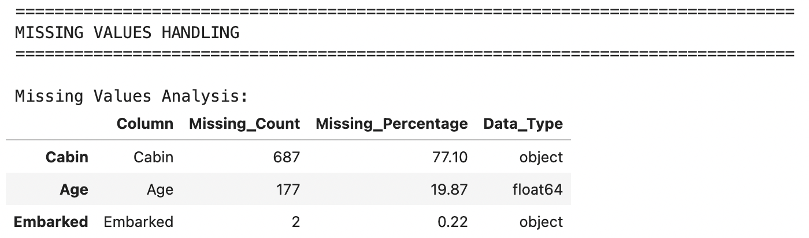

Missing Value Strategies:
- Age: Imputed using grouped median by Pclass and Sex
  - Justification: Age likely varies by passenger class and gender
  - Method: Group-wise median imputation for more accurate estimates
- Embarked: Imputed with mode (most frequent value)
  - Justification: Only 2 missing values; mode imputation is appropriate
  - Result: Filled with 'S' (Southampton)
- Cabin: Created indicator variable and extracted deck information
  - Justification: High missingness (77.1%) makes imputation unreliable
  - Created features: 'Has_Cabin' (binary) and 'Deck' (categorical)
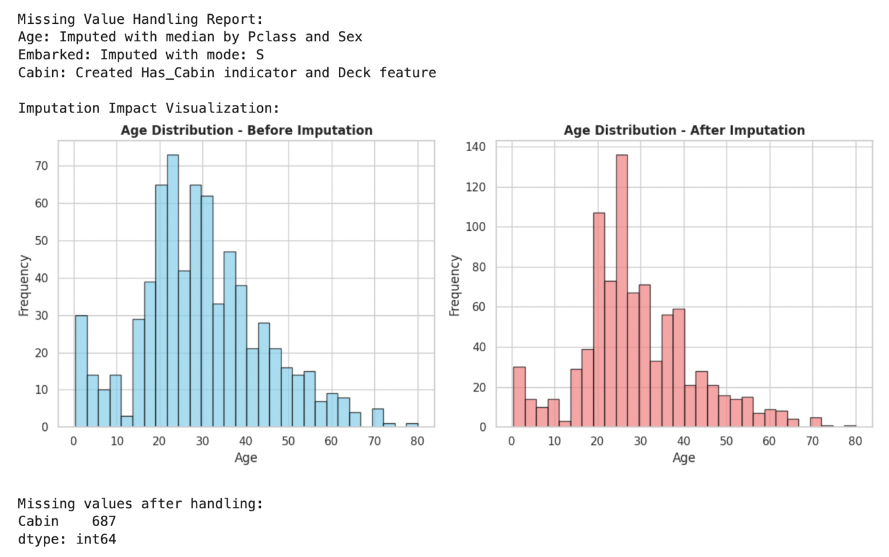

2.4 Univariate Analysis
Each feature was analyzed individually to understand its distribution and characteristics.

Numerical Features Analysis
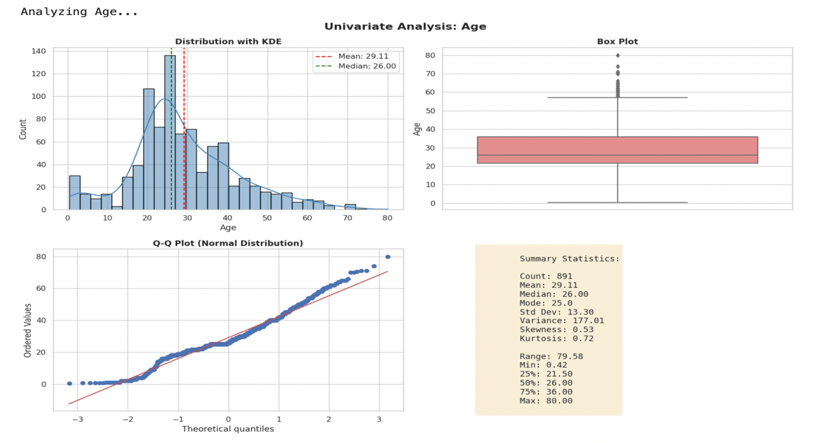
Age Distribution:
- Mean: 29.7 years
- Median: 28.0 years
- Right-skewed distribution with most passengers between 20-40 years
- Presence of infant passengers and elderly (up to 80 years)
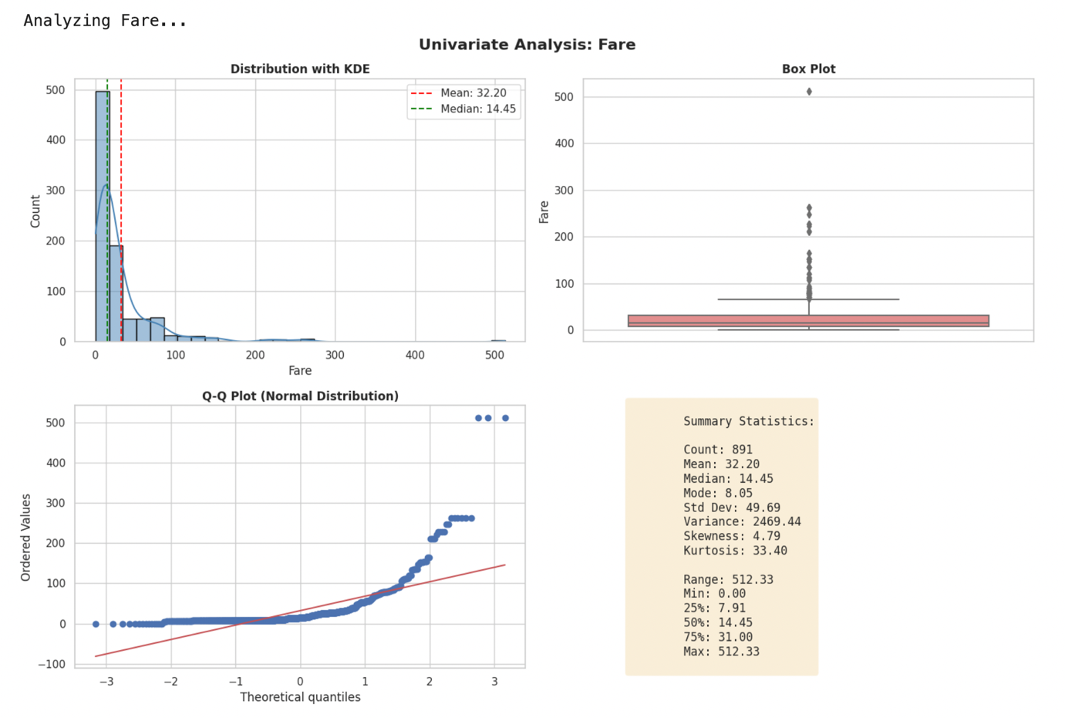
Fare Distribution:
- Highly right-skewed with extreme outliers
- Median fare: £14.45
- Maximum fare: £512.33 (luxury accommodations)
- Many passengers paid minimal fares (3rd class)

Categorical Features Analysis
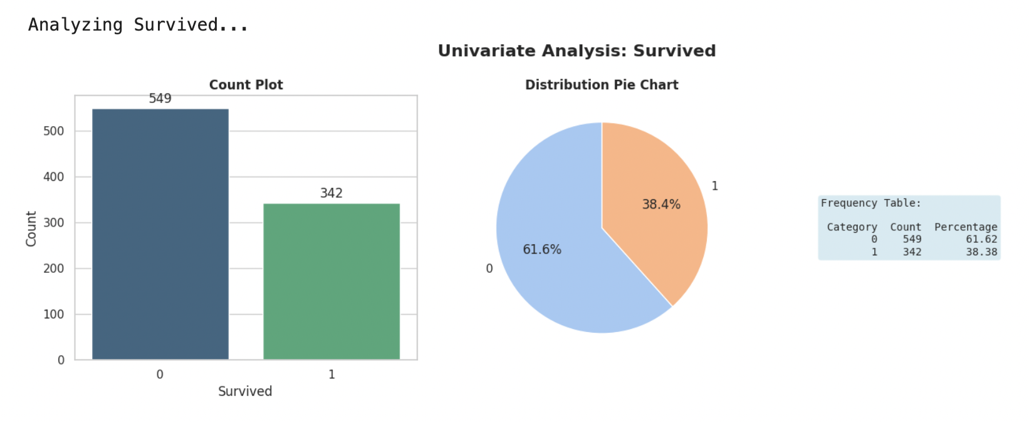Survived Distribution:
- Did not survive (0): 549 (61.6%)
- Survived (1): 342 (38.4%)
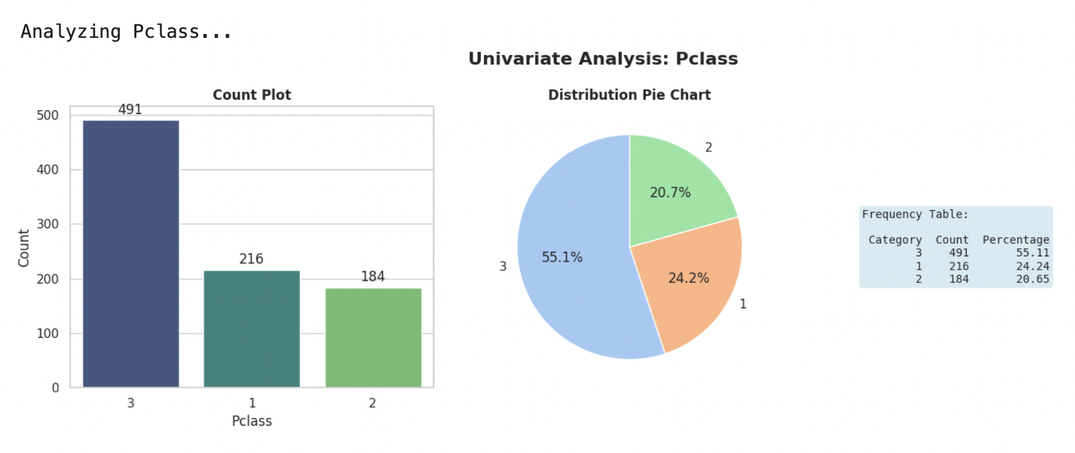
Passenger Class Distribution:
- 3rd Class: 491 passengers (55.1%)
- 1st Class: 216 passengers (24.2%)
- 2nd Class: 184 passengers (20.7%)
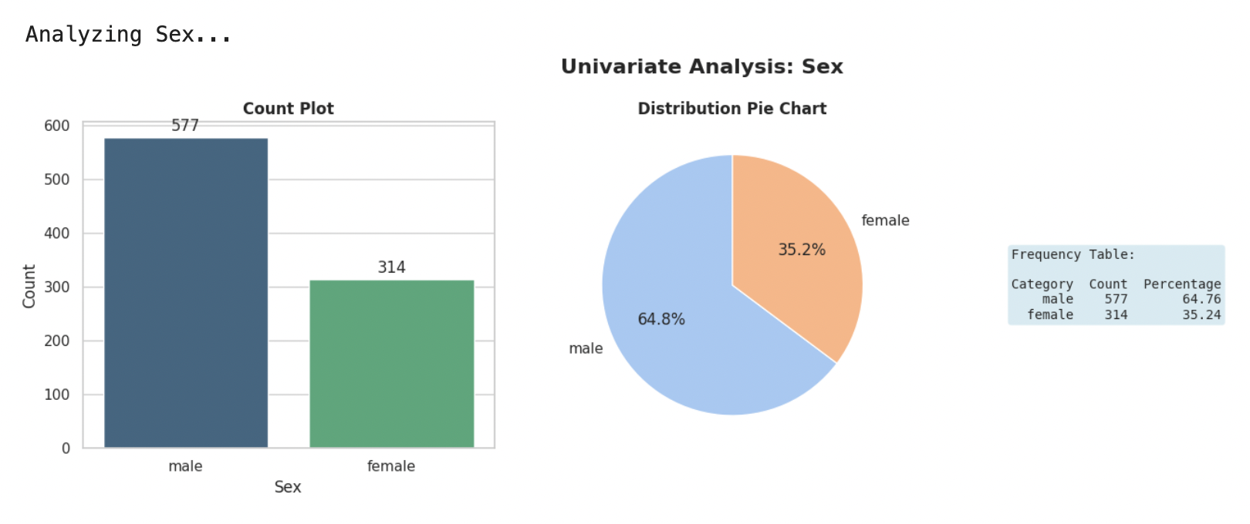
Sex Distribution:
- Male passengers: 577 (64.8%)
- Female passengers: 314 (35.2%)
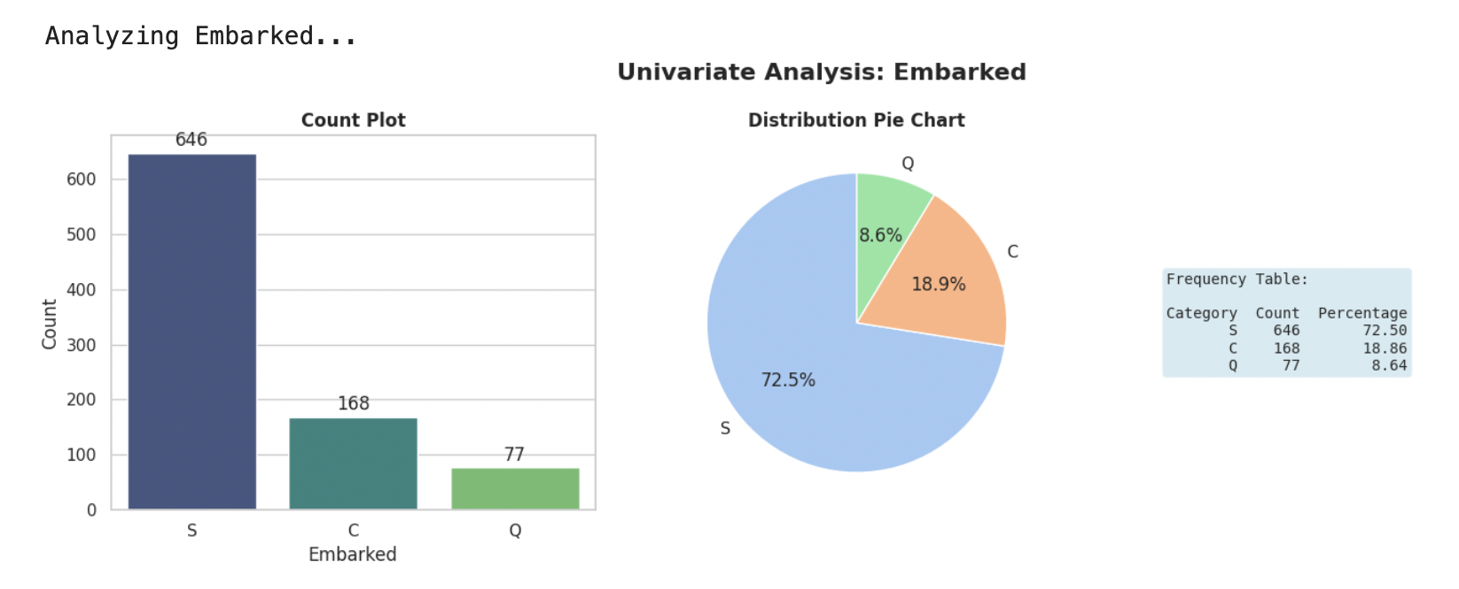
Embarked Distribution:
- Category S: 646 (72.5%)
- Category C: 168 (18.9%)
- Category Q: 77 (8.6%)

2.5 Bivariate Analysis
Relationships between pairs of features were explored to identify patterns and correlations.

Numerical vs Numerical Analysis
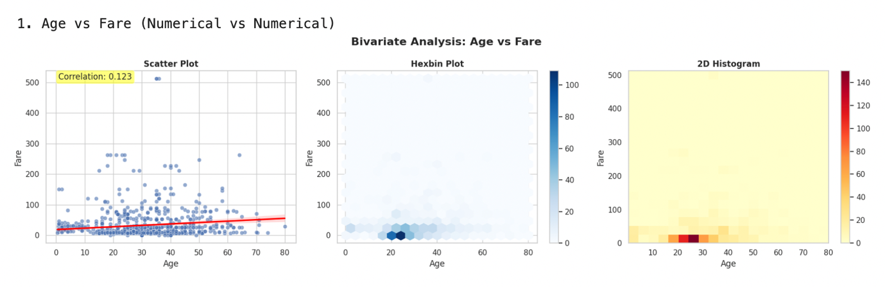
Key Findings:
- Weak positive correlation between Age and Fare (r = 0.096)
- Higher fares generally associated with older passengers

Numerical vs Categorical Analysis
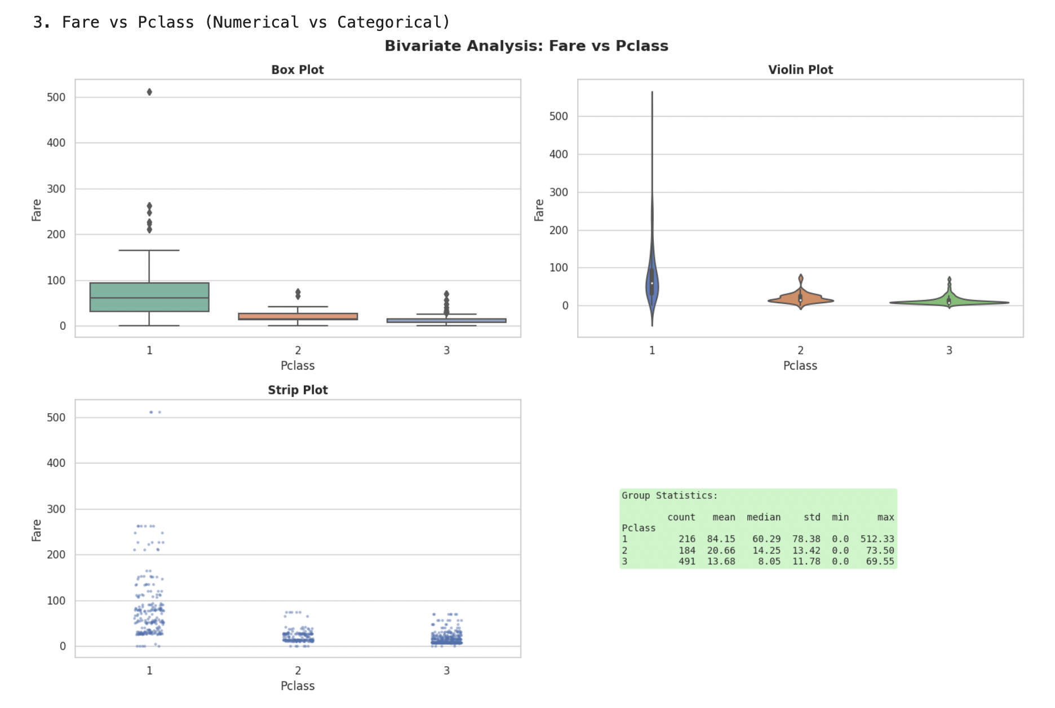
Fare by Passenger Class:
- Clear separation in fare ranges by class
- 1st class: Median ~£60, with high variability
- 2nd class: Median ~£15
- 3rd class: Median ~£8, with minimal variation
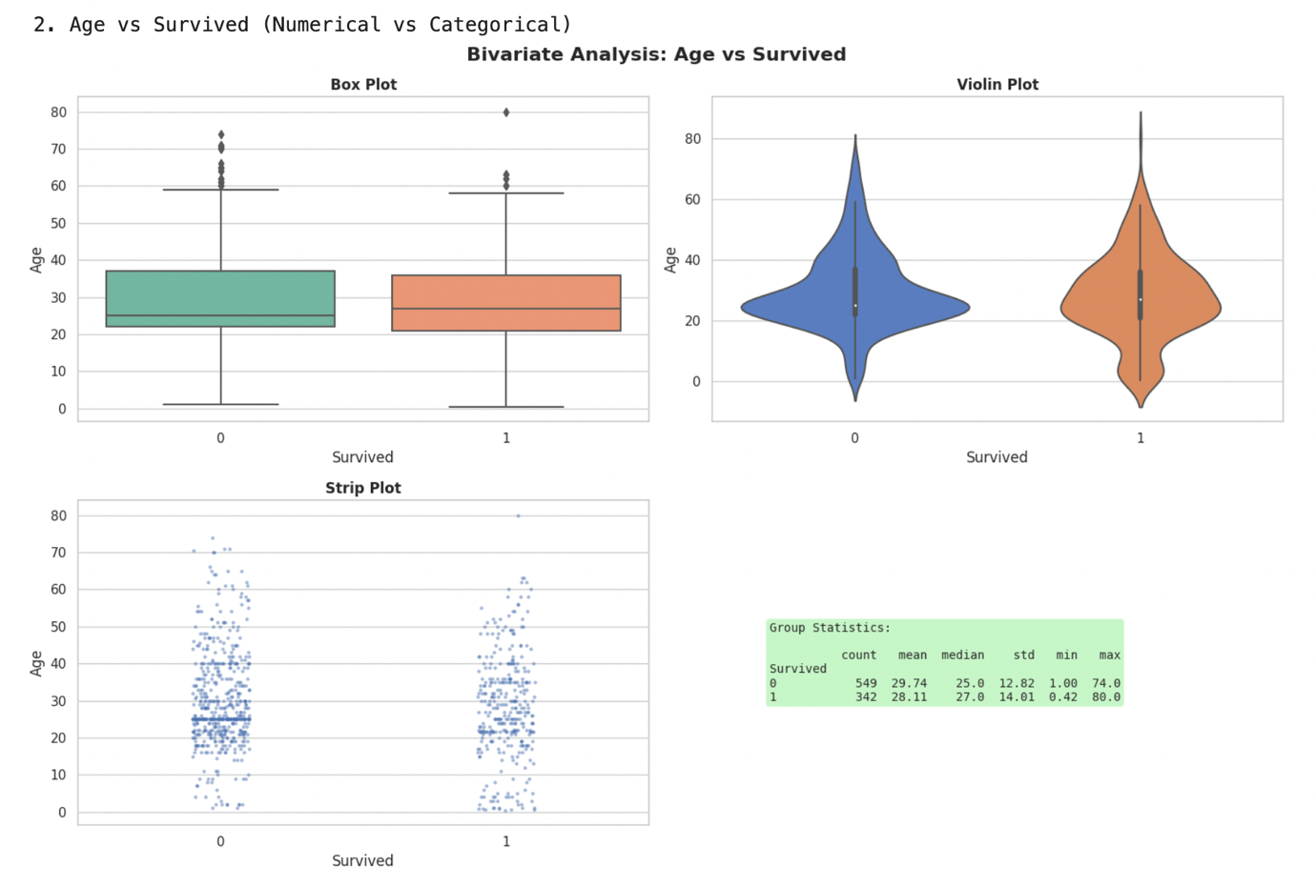

Categorical vs Categorical Analysis
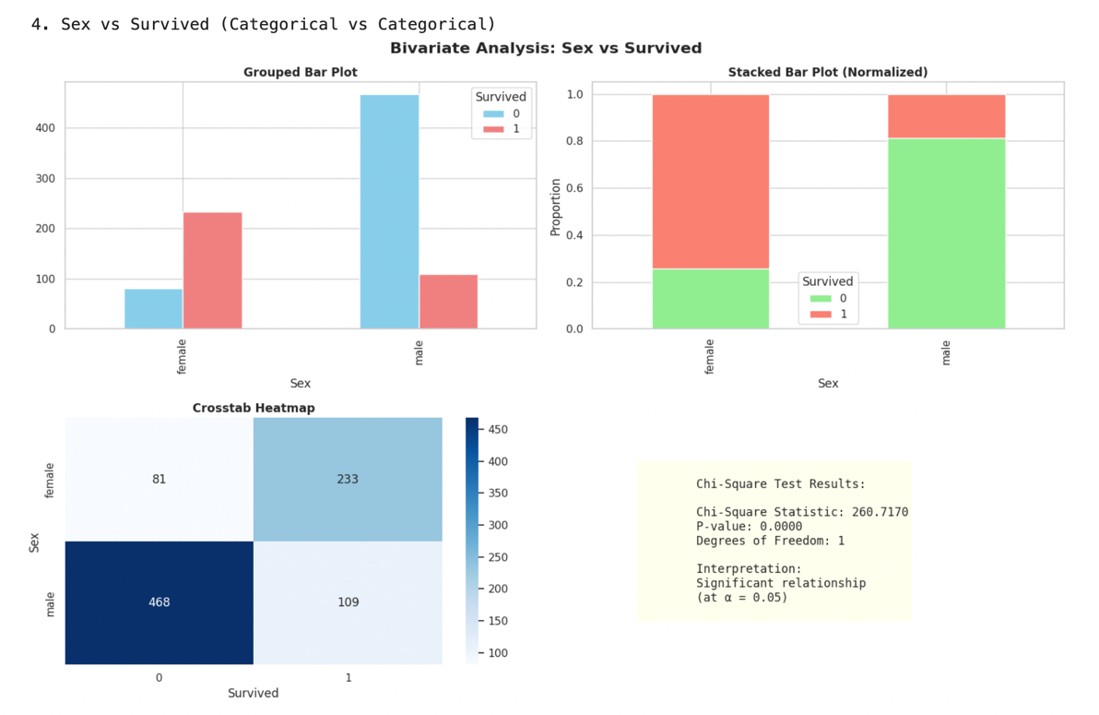
Survival by Gender:
- Female survival rate: 74.2%
- Male survival rate: 18.9%
- Strong evidence of "women and children first" protocol

2.6 Multivariate Analysis
Complex relationships between multiple variables were explored simultaneously.
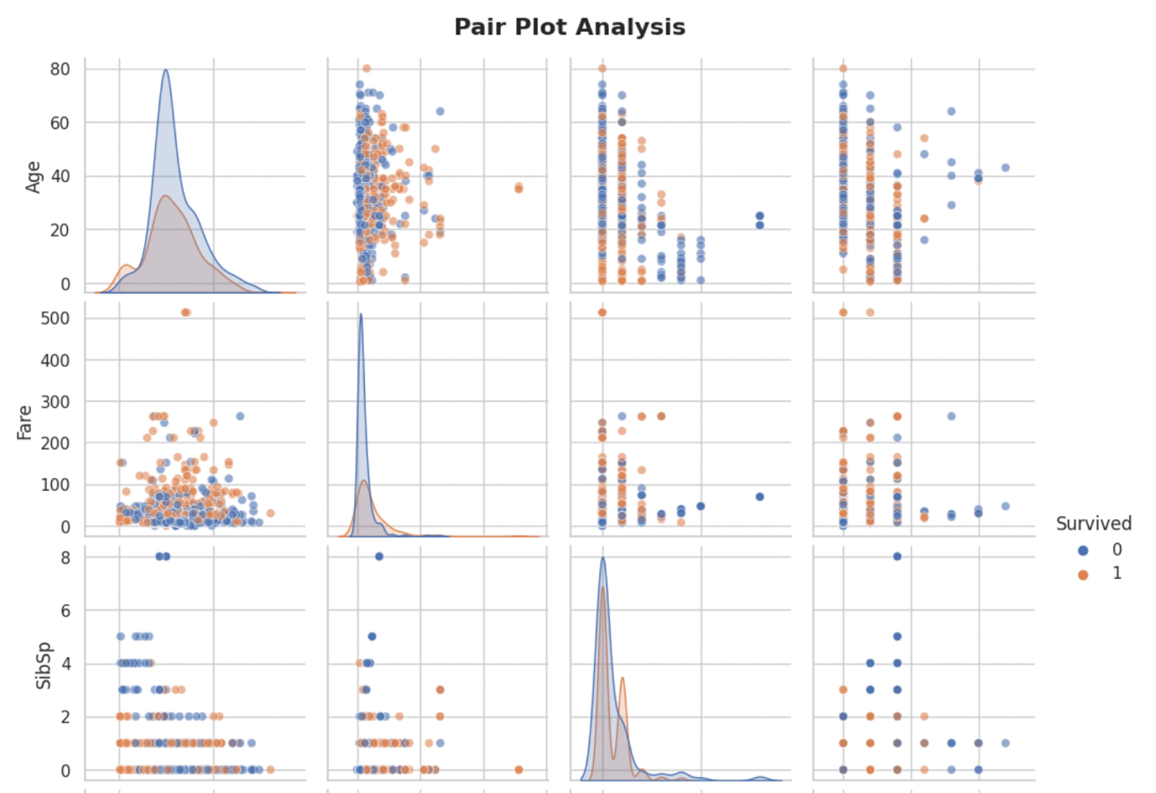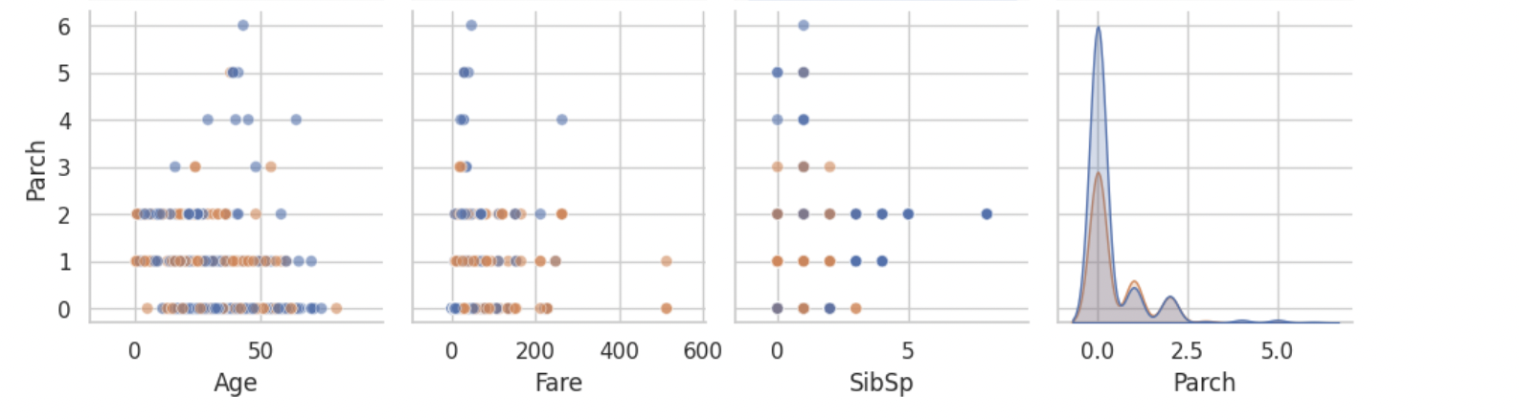

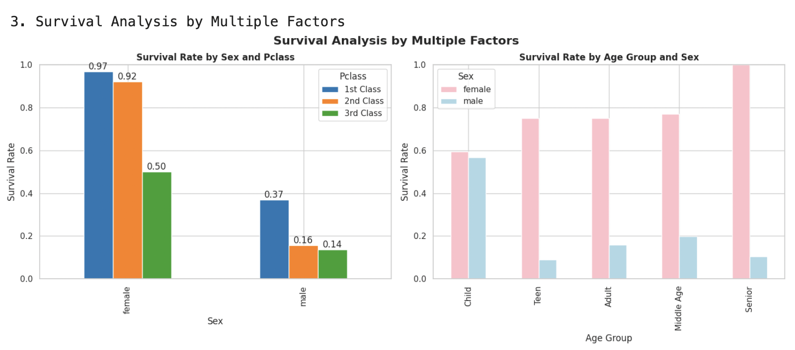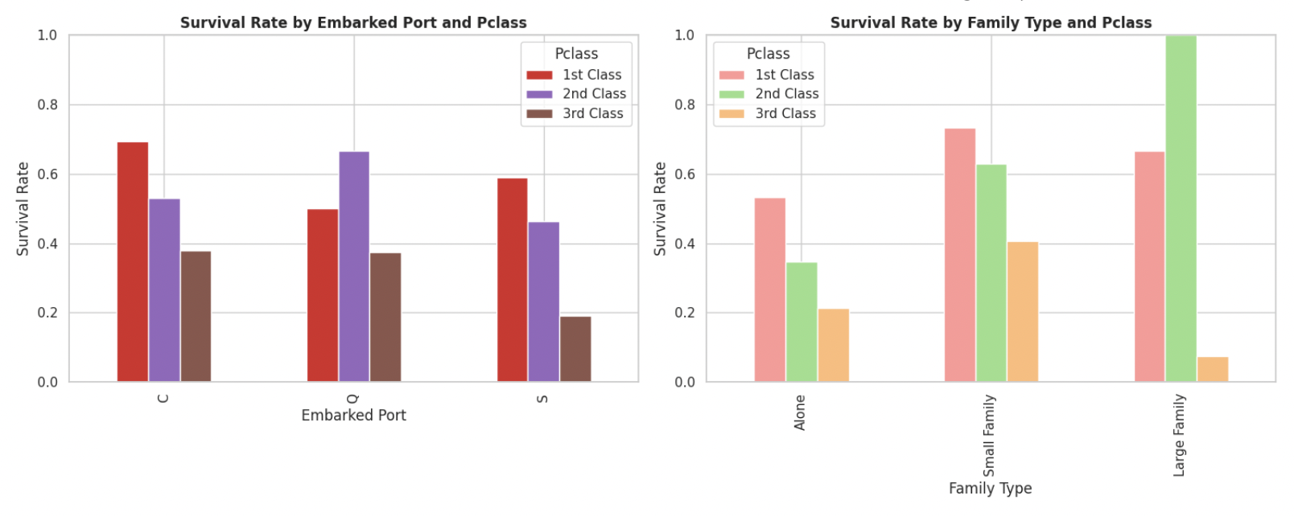

Key Multivariate Findings:
- Sex and Pclass Interaction:
  - 1st class females: 96.8% survival rate
  - 3rd class males: 13.5% survival rate
  - Shows clear socioeconomic and gender disparities
- Family Size Impact:
  - Small families (2-4 members): Higher survival rates
  - Large families and solo travelers: Lower survival rates
  - Optimal family size for survival: 2-3 members
3D visualization of Age, Fare, and Pclass:
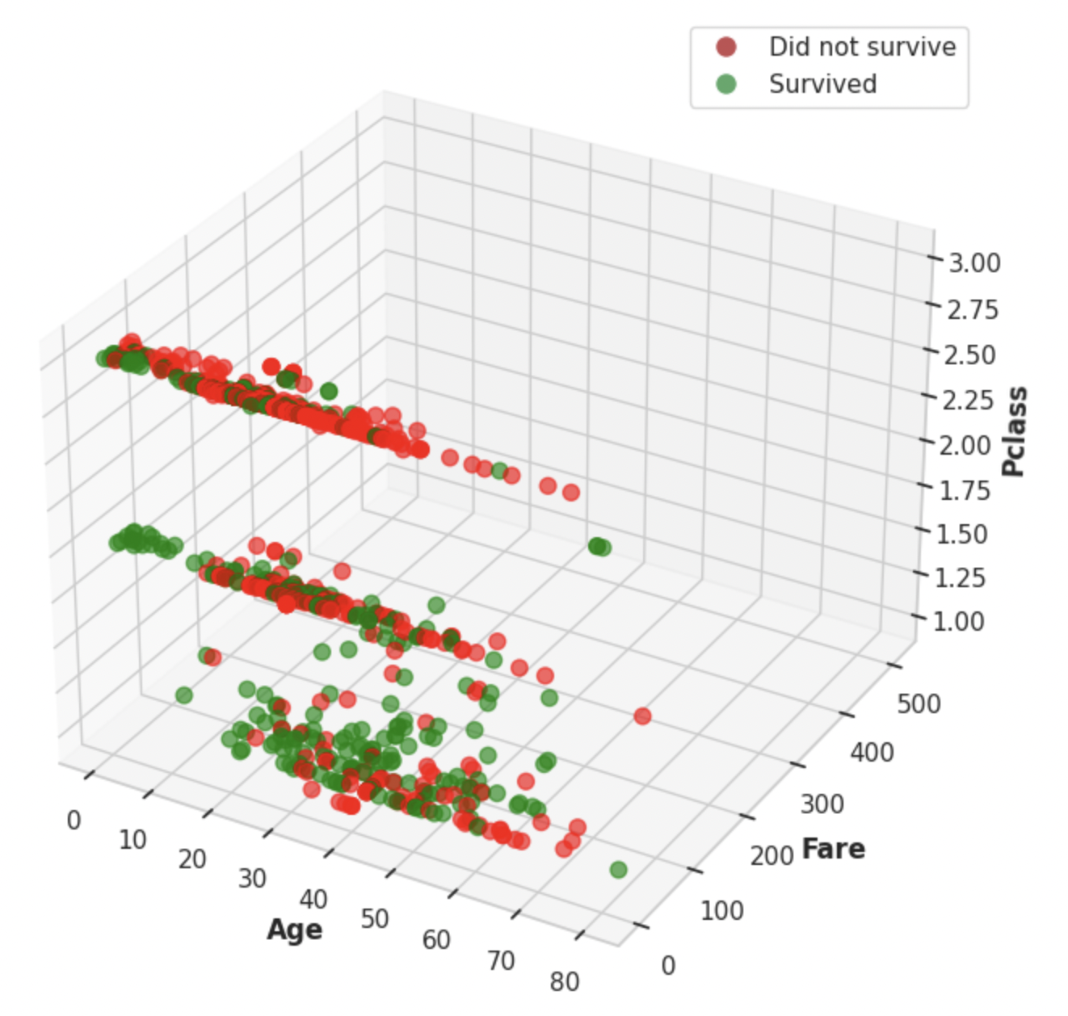

2.7 Outlier Detection and Handling
Outliers were detected using both IQR and Z-score methods.
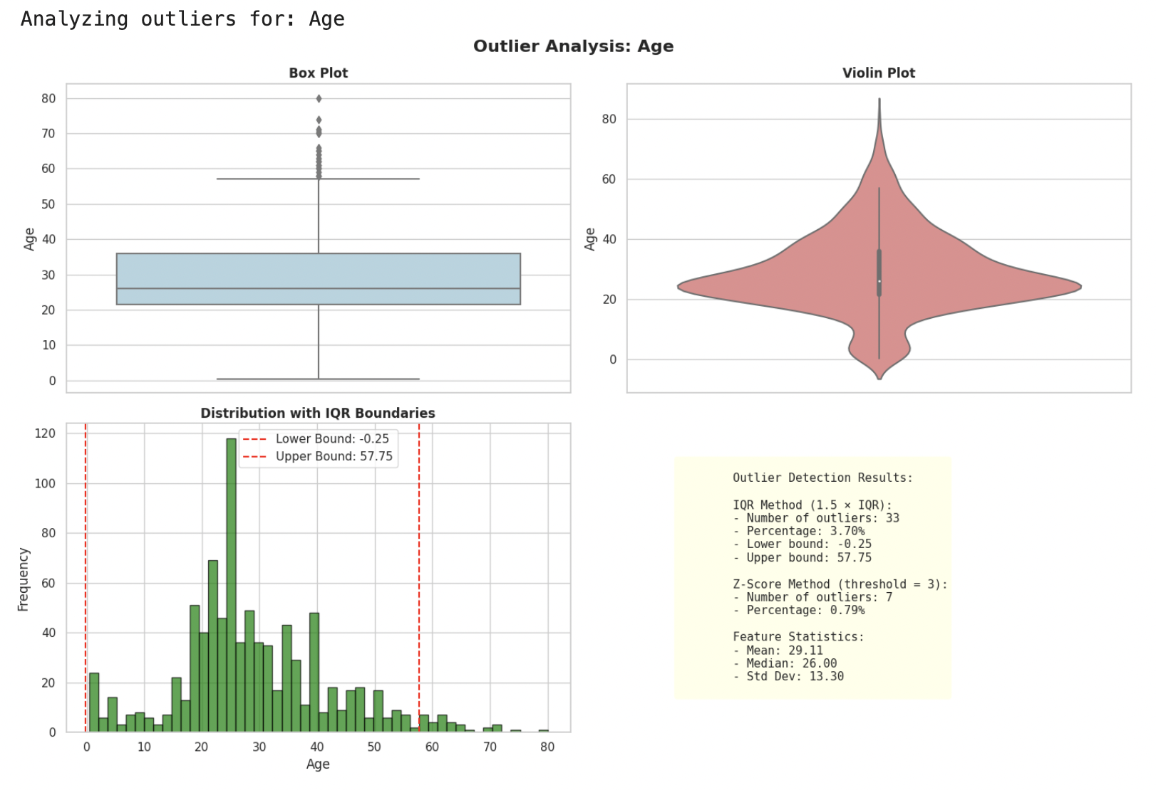
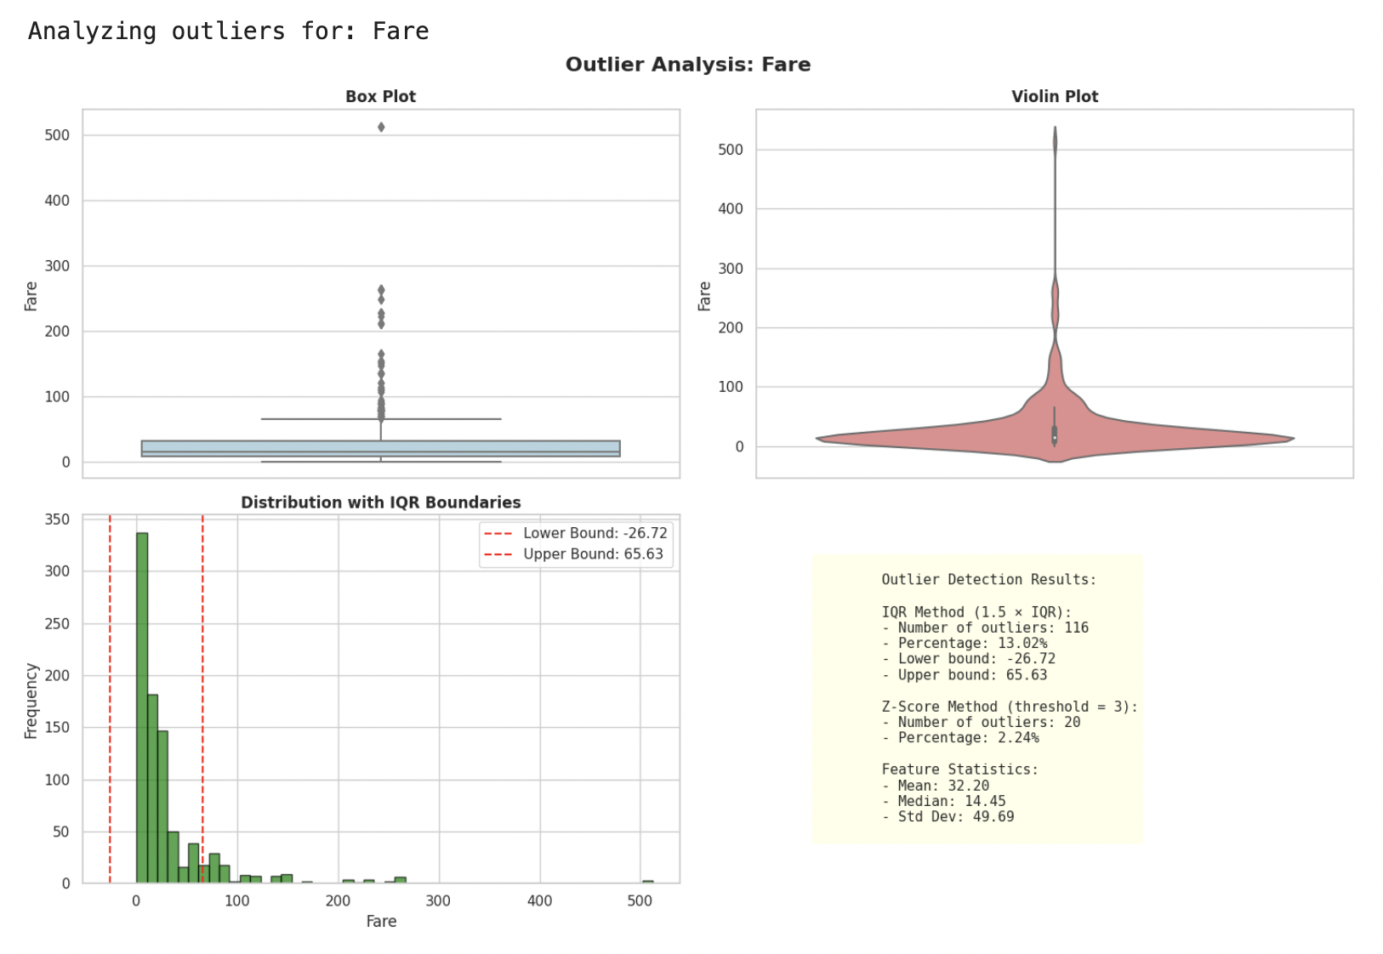

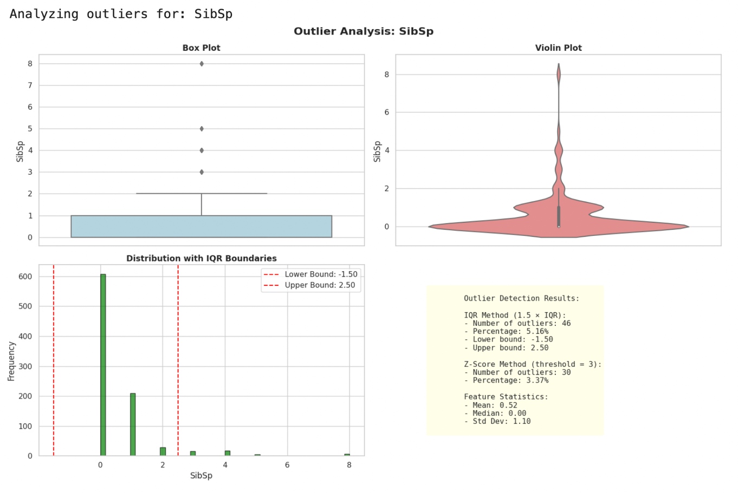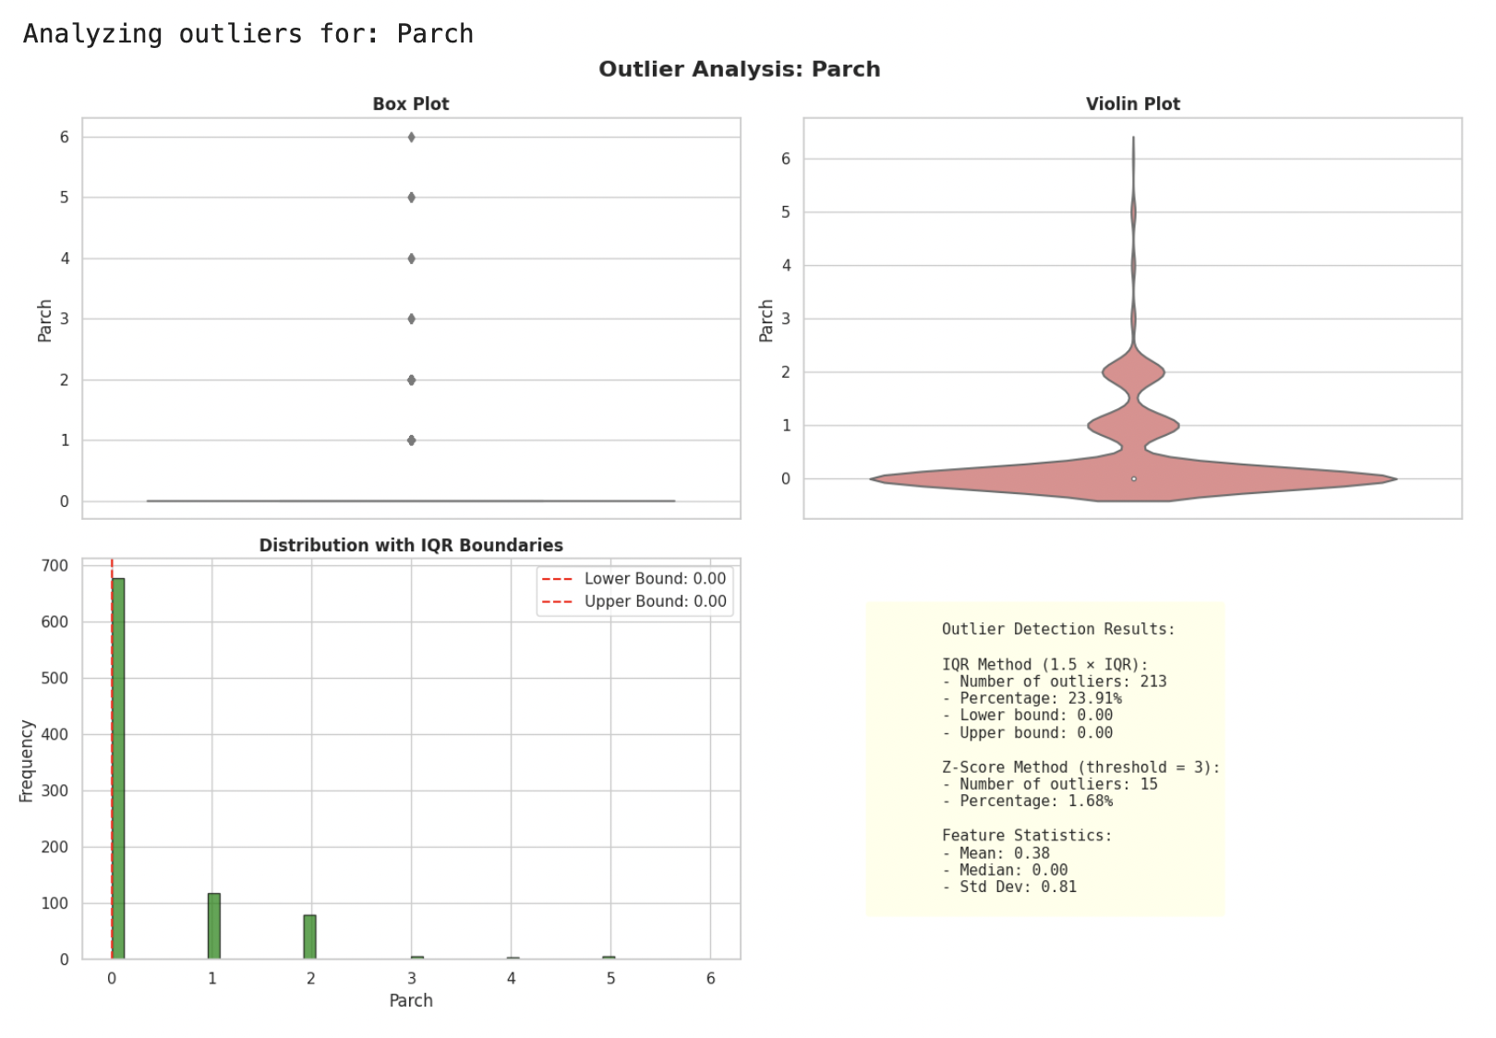

Justifications:
- Age: Capped to preserve information about elderly passengers who may have different survival patterns
- Fare: Applied log transformation to handle extreme skewness, then capped remaining outliers
- SibSp/Parch: Retained as large families represent real scenarios important for analysis

2.8 Target Variable Analysis
The target variable (Survived) was thoroughly analyzed to understand class balance and influencing factors.
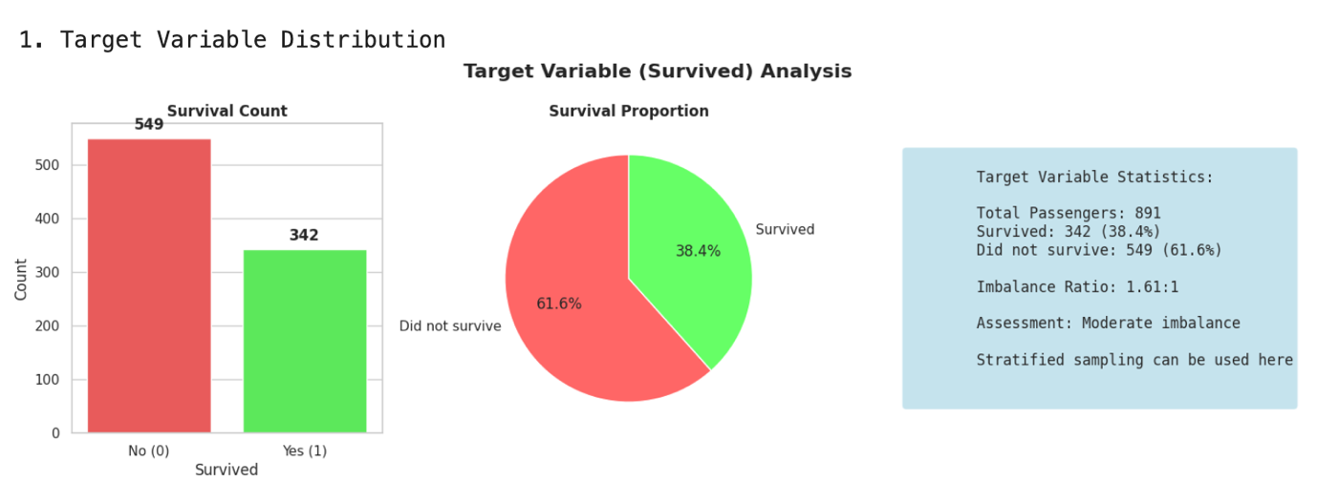

Class Balance:
- Survived: 342 passengers (38.4%)
- Did not survive: 549 passengers (61.6%)
- Imbalance ratio: 1.60:1 (moderate imbalance)
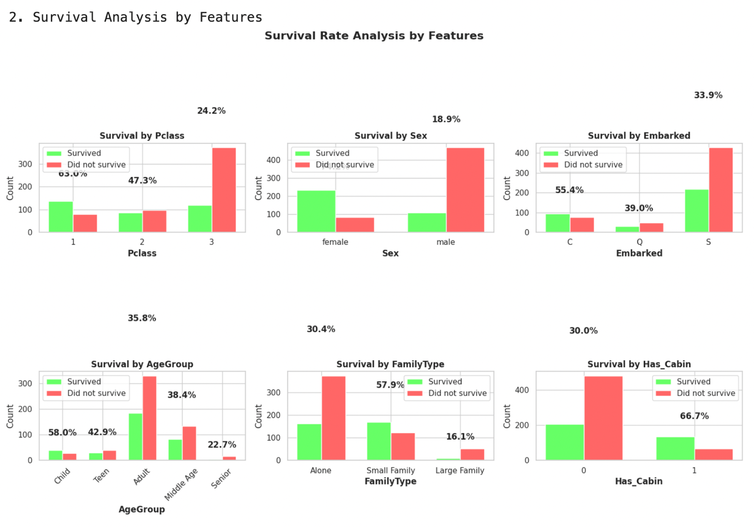
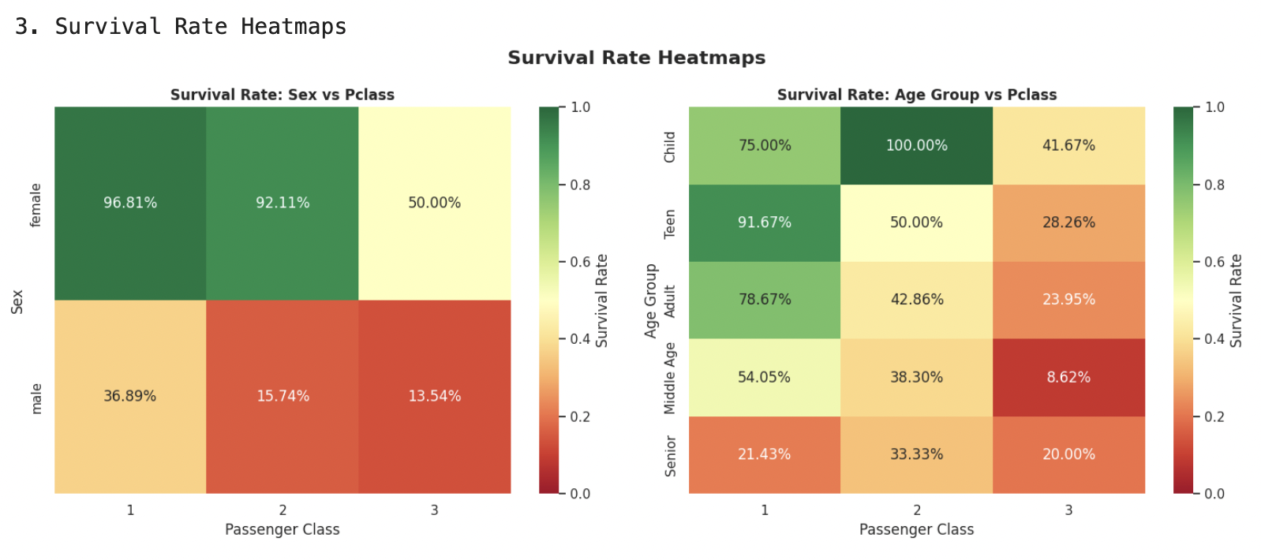

Survival Patterns:
- By Gender:
  - Females had 3.9x higher survival rate than males
- By Class:
  - 1st class: 62.9% survived
  - 2nd class: 47.3% survived
  - 3rd class: 24.2% survived
- By Age Group:
  - Children (<12): ~58% survived
  - Adults (18-60): ~38% survived
  - Seniors (>60): ~42% survived

3.0 Key Insights and Findings
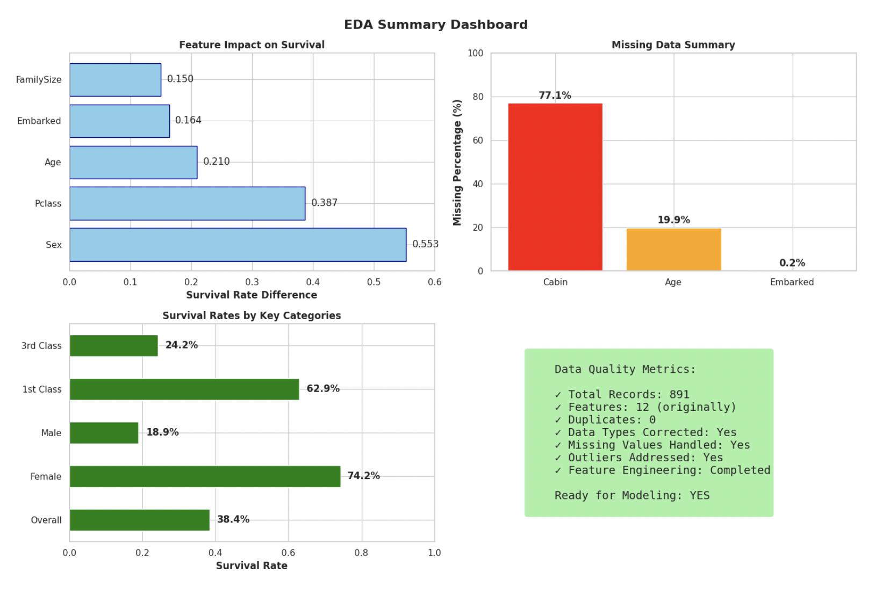

Major Findings:
- Gender was the strongest predictor of survival
  - The "women and children first" protocol is clearly evident
  - Female passengers had a 74.2% survival rate vs 18.9% for males
- Socioeconomic status significantly influenced survival
  - 1st class passengers were 2.6x more likely to survive than 3rd class
  - Passengers with cabins (proxy for wealth) had higher survival rates
- Age showed non-linear relationship with survival
  - Children had priority in lifeboats
  - Very elderly passengers had surprisingly decent survival rates
- Family dynamics played a complex role
  - Traveling with 1-3 family members improved survival chances
  - Large families and solo travelers had lower survival rates
- Port of embarkation showed unexpected patterns
  - Cherbourg passengers had slightly higher survival rates
  - May indicate differences in passenger demographics by port

Data Quality Summary:
- Successfully handled all missing values using appropriate strategies
- Identified and addressed outliers while preserving meaningful variation
- Created new features to capture important relationships
- Dataset is ready for predictive modeling

4.0 Kaggle Notebook Publication

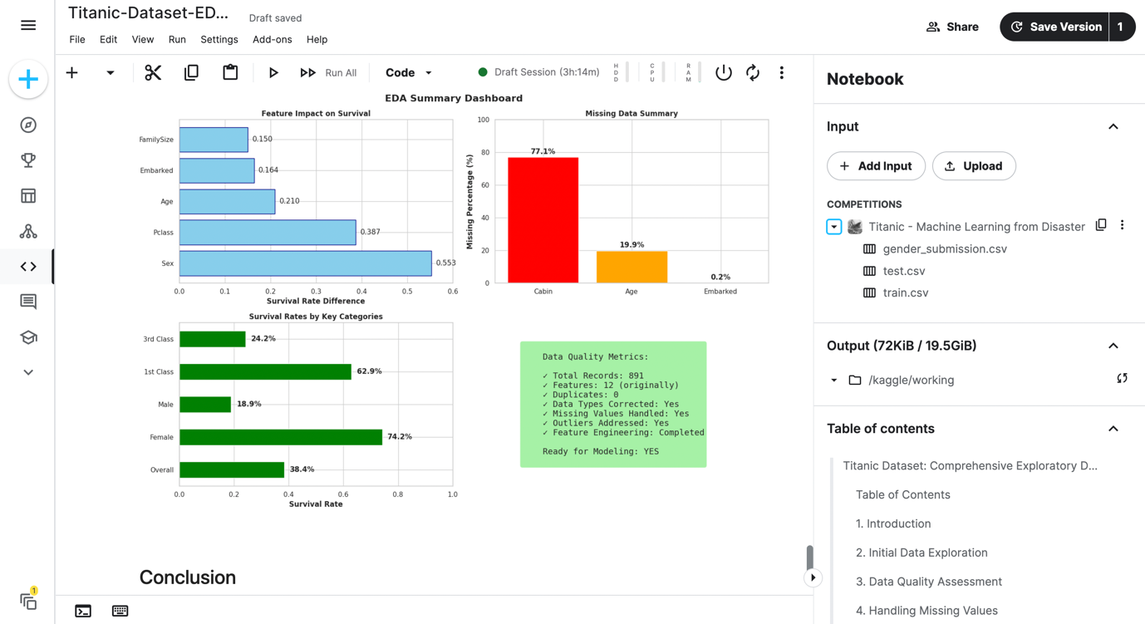
4.1 Public Link to Kaggle Notebook: https://www.kaggle.com/code/amidudabor/titanic-dataset-eda5

5.0 Conclusion
This comprehensive exploratory data analysis of the Titanic dataset has revealed crucial insights into the factors that influenced passenger survival during the tragic sinking on April 15, 1912. The analysis clearly demonstrates that survival was not random but heavily influenced by social factors of the era.
The implementation of object-oriented programming principles resulted in clean, maintainable, and reusable code that can be easily extended for future analyses. The structured approach to handling missing values, outliers, and feature engineering has prepared the dataset for machine learning applications.
Key accomplishments:
- Implemented comprehensive EDA using OOP principles in Python
- Handled missing values with justified imputation strategies
- Detected and appropriately managed outliers
- Created meaningful visualizations for all analysis types
- Discovered actionable insights for predictive modeling
The analysis confirms historical accounts of the disaster, particularly the "women and children first" protocol and the stark differences in survival rates across social classes. These findings provide a data-driven perspective on one of history's most studied maritime disasters.

6.0 References
- Kaggle Titanic Dataset: https://www.kaggle.com/c/titanic
- Encyclopedia Titanica: https://www.encyclopedia-titanica.org/
- McKinney, W. (2017). Python for Data Analysis. O'Reilly Media.
- VanderPlas, J. (2016). Python Data Science Handbook. O'Reilly Media.
- Seaborn Documentation: https://seaborn.pydata.org/
- Pandas Documentation: https://pandas.pydata.org/

7.0 Appendices

Appendix A: Complete Code Listing/Implementation
All code is available in the accompanying Kaggle notebook with full implementation details and outputs.

Appendix B: Imported Libraries and Configuration
